Dear Sponsor,

On behalf of the ***Infusion*** 2024 Management Team, we would first like to thank you for taking interest in our eleventh annual ***Infusion*** competition held on March 16th, 2024 at The Pennsylvania State University.

We are the Sponsorship Directors of ***Infusion***, a non-profit intercollegiate South Asian dance competition. ***Infusion*** invites teams within the North American Filmi-Fusion circuit to compete at our competition for a cash prize and a bid to the continental Filmi-Fusion championship: Bollywood America. With an anticipated crowd of more than 1,500 attendees in the Eisenhower Auditorium, ***Infusion*** 2024 promises to be truly memorable for each individual involved. Unlike any other competition, for participants, ***Infusion*** is a weekend long experience, and the memories will begin the moment they arrive at the competition hotel on Friday, March 15th until they leave on the morning of Sunday, March 17th. Their weekend will consist of a mixer to socialize with other teams, various rehearsals, the competition itself, and a celebratory social to finish off the weekend.

In order to accomplish our vision as this year’s Sponsorship Directors, we rely heavily on our corporate and local sponsors. With your organization’s help, ***Infusion*** will be able to showcase South Asian culture through this unique fusion of Bollywood and western dance styles to the public. Your association with us will allow ***Infusion*** to attract new audience members who wish to immerse themselves in the competition. Since we are responsible for providing teams with all meals, prizes, and any necessary items throughout the weekend, we ask for any donation that you can provide to us in helping us achieve this hospitality. As our competition is focused on the foundation of philanthropy, your efforts will contribute to the annual, 46-hour Penn State IFC/Panhellenic Dance Marathon (“THON”), which has raised millions of dollars towards pediatric cancer research at the Penn State Hershey Medical Center. In addition, we are also contributing to Feeding America. Moreover, since we are a non-profit under the 501(c) (3) United States Internal Revenue Code, all of your donations will be tax deductible.

We invite you to be a sponsor at the tenth annual ***Infusion*** dance competition. Any donation, whether in the form of cash, gift certificates, or tangible items, will be instrumental in assisting us to reach our goals. Your business will have the opportunity to be listed on all our advertising and press as a sponsor of this event. Along with the benefits we provide listed on page 5 of this packet, we are also willing to work with you for any additional promotional opportunities to drive traffic to your business.

Please contact us if any additional information is needed to answer any of your questions. We thank you for your time, and we look forward to working with you!

Sincerely,

***Infusion*** Sponsorship Directors

Pradham Bathini & Shreshty Budakoti

[sponsorship@pennstateinfusion.org](mailto:sponsorship@pennstateinfusion.org)

What is Filmi-Fusion Dance?

Filmi-Fusion Dance is one of the newest and fastest growing South Asian dance genres in North America. Entertaining crowds throughout the continent for the past decade, Filmi Fusion combines two distinct dance styles: Hindi Film Dance (HFD) and Fusion. HFD focuses on traditional Bollywood themes, from romantic fairy tales to thrilling suspenses and social movements, expressed to popular Bollywood tracks. Fusion, on the other hand, blends a variety of South Asian dance styles with various western dance forms such as hip-hop, ballet and lyrical. As the South Asian community in North America continues to grow and experience success in global music and cinema, Bollywood is becoming a household term. Because of the increasing popularity of South Asian culture, audiences are enticed by the storytelling masterpieces that Filmi-Fusion teams showcase at ***Infusion***.

What is THON?

The Penn State IFC/Panhellenic Dance MaraTHON is an annual, year-round fundraising event for The Four Diamonds Fund, at the Penn State Children’s Hospital in Hershey, PA. Over the past 40 years, the students of Penn State have raised over $80 million and continue to lend support to thousands of children and families fighting pediatric cancer. The year culminates in a no-sitting, no-sleeping, 46-hour dance maraTHON held every February. Over the years, THON has raised more than $136 million to support families in paying for pediatric cancer treatment and facilitate research. This collective effort, involving more than 16,000 students, has become one of Penn State’s greatest and most unifying traditions. As a percentage of ***Infusion’***s proceeds goes towards THON, your sponsorship could benefit a great cause.

What is the impact of your sponsorship?

Your sponsorship and association with ***Infusion*** will help your organization expose its name to thousands of future leaders from universities throughout the country. The target audience will extend beyond college students and reach out to a community that holds tradition, culture, and values with the utmost respect. Your sponsorship will reach an extensive crowd at a minimal cost and will not be limited by geographic region. The main audience your organization will be exposed to includes (but is not limited to) the South Asian community, which is home to nearly 10% of the United States’ millionaires. With this in mind, it is very clear why so many businesses and organizations have turned their marketing efforts to attract such a financially powerful demographic of the American community. ***Infusion***’s advertising efforts have already commenced at various college campuses and major cities throughout the United States. More importantly, ***Infusion*** is being held at the Pennsylvania State University, which is home to over 48,000 undergraduate students and thousands of graduate students, faculty and community members.

What is Eisenhower Auditorium?

The venue of ***Infusion*** 2024 is the 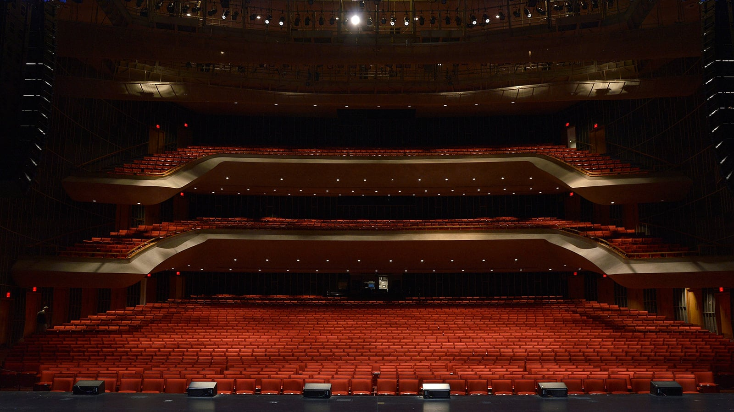

prestigious Eisenhower Auditorium,

which can accommodate up to 2,500

people. Eisenhower Auditorium is

Penn State’s primary theatrical

performance space and is also one of

the largest stages in the country.

Opened in 1974 and later named after

the former University President,

Milton S. Eisenhower, the modern

style auditorium hosts more than 200

events each year. Famed artists and

ensembles have graced Eisenhower’s

stage and mesmerized the State

College community throughout the

years.

Who are the organizers behind ***Infusion*** 2024?

Consisting of past members of the ***Infusion*** 2023 management team, the team has gained considerable knowledge and expertise by traveling across the nation and participating in a variety of Filmi-Fusion competitions. After six successful years in the filmi-fusion circuit, the ***Infusion*** board is back for its tenth season, and promises to make it even bigger and better

than before. It continues to firmly believe in the values our founders passed down to us, pledging to move forward with the same sincerity, hospitality and entertainment. Above all, the ***Infusion*** management team has come together to organize a competition that would provide the nation with the finest of South Asian culture.

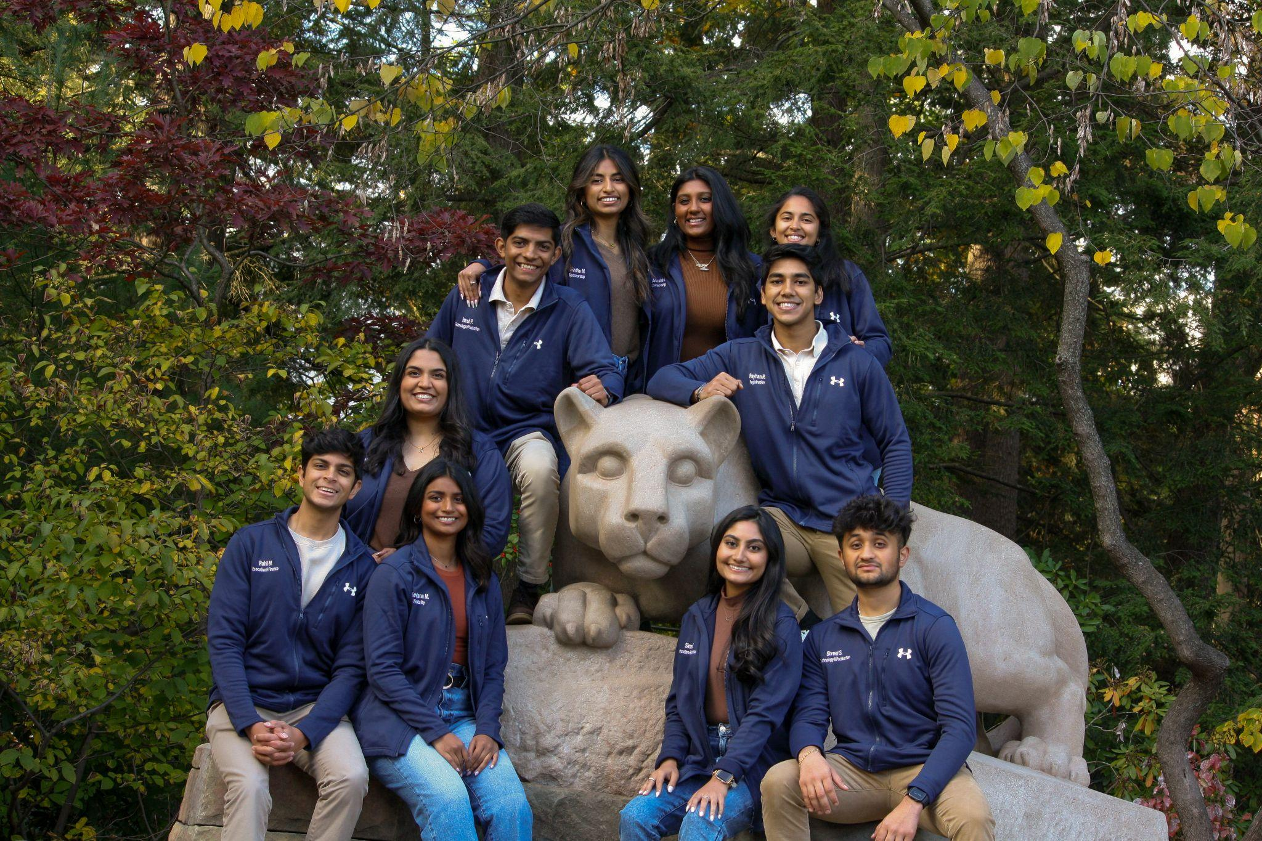

| Sponsorship Level | Supporting | Leading | Premium | Elite |
| --- | --- | --- | --- | --- |
| Contribution | $500-$999 | $1000-$1499 | $1500-$1999 | $2000+ |
| Competition Benefits | | | | |
| VIP Tickets to Infusion | 5 | 10 | 15 | 20 |
| Advertising | | | | |
| Logo on Infusion Website | x | x | x | x |
| Logo on all Infusion social media pages | x | x | x | x |
| Logo on Infusion introduction Video |  | x | x | x |
| Logo on Infusion t-shirts |  |  | x | x |
| Logo on Infusion Banners |  |  | x | x |
| Logo on show programs |  |  | x | x |
| Logo on all Promotional fliers |  |  |  | x |
| Name announced during show |  |  |  | x |
| Short commercial during intermission |  |  |  | x |

If you would like any additional information regarding sponsorship or any other partnership ideas, please contact the ***Infusion*** sponsorship team at  **sponsorship@pennstateinfusion.org** or by phone: Pradham Bathini **(717-440-3171)** Shreshty Budakoti **(774-287-4621)**

The terms and conditions outlined herein have been established for the mutual benefit and protection of the Sponsor, ***Infusion*** Management Team, and event patrons. These terms may not be modified unless in writing and signed by the first two parties listed above. The Sponsor agrees to these terms and conditions as an integral part of this binding contract. Please read carefully to avoid any misunderstandings.

1) Checks, cashier’s checks, and money orders are acceptable forms of payment. Sponsorship benefits are conditional upon payment of the mutually agreed sponsorship fee. The sponsorship fee is due at the time of commitment and payment in full is due prior to the event in any case.

2) The sponsorship benefits listed in this document for each respective sponsorship level constitute the entire package of benefits offered to sponsors. The ***Infusion*** Management Team is under no obligation to provide additional benefits if not mentioned in this document, whether promised otherwise or not, unless agreed in writing by the Sponsorship Directors of the ***Infusion*** Management Team.

3) Unless prohibited in writing by the Sponsor, the Sponsor permits the ***Infusion*** Management Team to use the Sponsor’s name and/or logo in promotional materials, advertising, and public announcements related to ***Infusion***. The Sponsor further represents and warrants that it has the right to grant this permission. The Sponsor will retain all ownership rights and any goodwill related to the use of its trademarks. The Sponsor shall hold the ***Infusion*** Management Team harmless against any and all actions related to the ***Infusion*** Management Team’s use of the Sponsor’s trademarks.

The ***Infusion*** Management Team reserves the right to decline the sponsorship support of any organization or firm.